New England Regional World History Association
Fall 2018 Symposium
“Cities in World History”
Buckingham Browne & Nichols School
3 November 2018

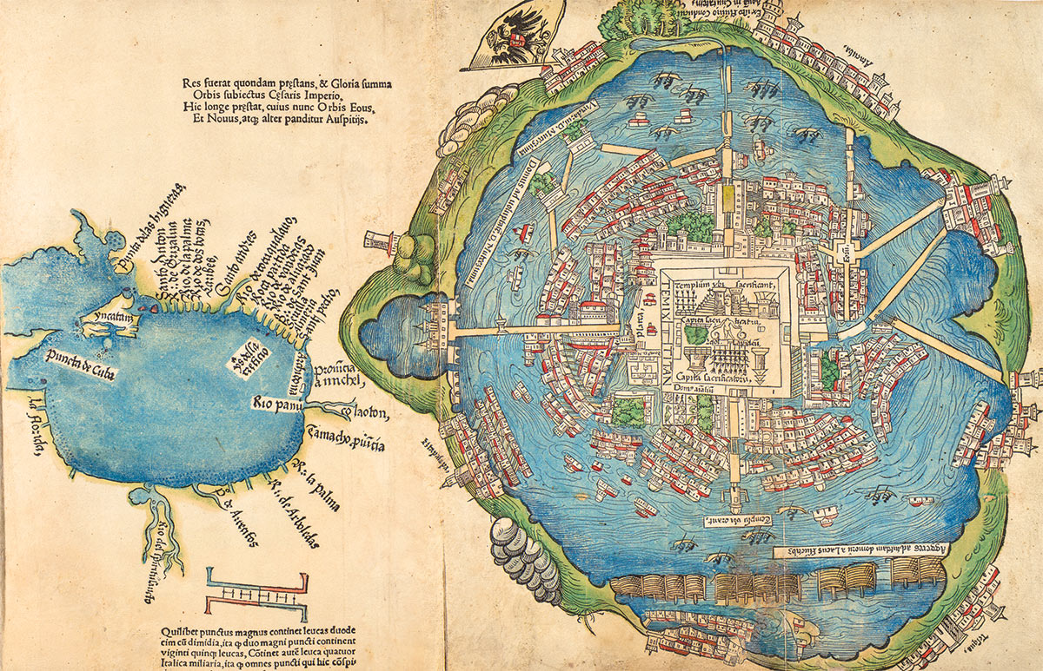
A 1524 Map of Tenochtitlan

9:00-9:30 Registration and Continental Breakfast
BB&N Student Posters on Display throughout the Day
Hackett Publishing Co. will display books throughout the day
Books by NERWHA members and symposium participants on display

9:30-9:45 Welcome
Susan D. Glazer, Upper School History and Social Sciences Department Head, Buckingham Browne & Nichols School
David Kalivas, NERWHA President

10:00-11:00 Keynote Address, Community Room
“City of the Crossroads: Tenochtitlan/Mexico City”
David Carrasco, Neil L. Rudenstine Professor of Latin America,
Harvard University
Introduction of Professor Carrasco, David Kalivas, Middlesex Community College

Session A11:05-12:35
Panel 1 Teachers’ Workshop, Community Room
“Monumental Errors: Getting History Wrong in Massachusetts Urban Spaces, and Why It Matters in World History,”
Thomas Pyke Johnson, University of Massachusetts, Boston and Bentley University

Panel 2: International Maritime Trade Ports, Room 106
Chair: Brandon Tacho, University of Hawai’i at Manoa
“From Spice to Coffee: Aden, Mocha, and the Global Ports of the Indian Ocean”
Thomas Anderson, Merrimack College
“Guangzhou and Salem: A Reciprocal Relationship?”
Dane Morrison, Salem State University
“Trading Slaves in Maritime Border Towns: Amelia Island and Galveston in the Nineteenth Century”
Sarah Batterson, Granite State College

Panel 3 Imperial Cities, Room 110
Chair: Michael S. Laver, Rochester Institute of Technology
“Naukratis: Between Egypt and the World
Erik Jensen, Salem State University
“Ancient Cities of the Americas”
Paul Jentz, North Hennepin Community College
“Trieste at the Crossroads: Business, Empire, and Identity in Trieste from Habsburg Port City to Fascist Italy’s Economic Hub”
Susan Glazer, Buckingham Browne & Nichols School

12:35-1:30 Lunch and NERWHA News, Community Room

Session B 1:30-3:00
Panel 4: A Teachers’ Round Table, Community Room
“Integrating ‘Cities in World History’ into High-School Curricula”
Chair: Lizanne Moynihan, Buckingham Browne & Nichols School
Farah DiPasquale, Buckingham Browne & Nichols School
Susan Glazer, Buckingham Browne & Nichols School
Lizanne Moynihan, Buckingham Browne & Nichols School
Matthew Turnbull, Buckingham Browne & Nichols School

Panel 5: Cities in a Global Context, Room 106
Chair: A. J. Andrea, University of Vermont
“Nineteenth-Century Glaswegian Shipbuilding: A Local International Business Community
Brandon Tacho, University of Hawai’i at Manoa
“Chinese New Year in Boston’s Chinatown: Global Tradition, Local Rendition”
Violetta Ravagnoli, Emmanuel College
“Oaxaca City: Mexico in World History Perspective”
Thomas Mounkhall, SUNY New Paltz

Panel 6 Cities on the Edge and In Between in Transcontinental Perspective, Room 110
Chair Thanasis Kinias: Northeastern University
“Precolonial Trading Cities in Sub-Saharan Africa”
David Northrup, Boston College
“Neither Here nor There: Port Cities as a ‘Space Between’ in Early Modern Japan”
Michael S. Laver, Rochester Institute of Technology
“Ruminations on the Role of Urban Centres in the Making of Frontier Genocides: Cape Town, Brisbane, and San Francisco Compared”
Mohamed Adhikari, University of Cape Town

3:00-3:15
Summary and Farewell
NERWHA acknowledges with gratitude the generous patronage of Buckingham Browne & Nichols School, the vision and support of two of its faculty members, Gustavo Carrera (now at Shore Country Day School) and Susan Glazer, and the continuing support of Hackett Publishing Co. of Cambridge, MA.

